Lab3-->Lec2
------------------------------------------------------------------------
Mohamed Ahmed Mohamed
-----------------------------------------------------------
1-Using vi write your CV in the file mycv. Your CV should include your name, age, school,

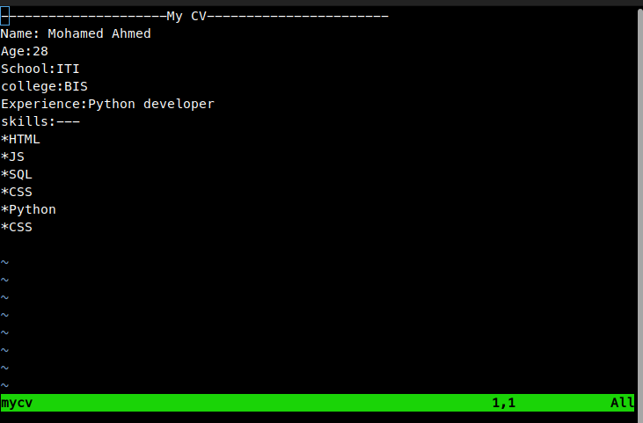
2- Open mycv file using vi command then: Without using arrows state how to:

a. Move the cursor down one line at time. [J]
b. Move the cursor up one line at time. [K]
c. Search for word age. [set ic][:/age]
d. Step to line 5 .[5G]
e. Delete the line you are on and line 5.[:.d|5d]
f. How to step to the end of line and change to writing mode in one-step. [A]

3. List the available shells in your system.
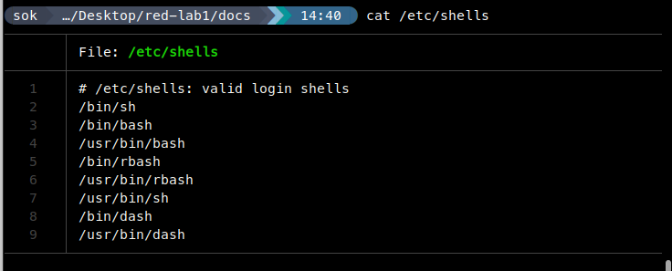
4. List the environment variables in your current shell.
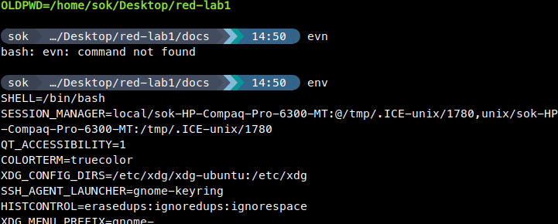
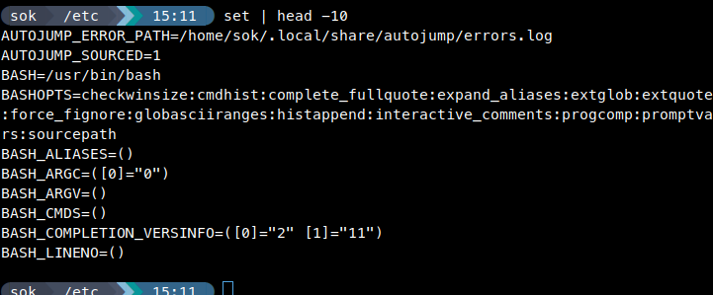
5. List all of the environment variables for the bash shell.
6-What are the commands that list the value of a specific variable?

7-Display your current shell name.


8- State the initialization files of: sh, ksh, bash.
1- sh bourne shell:
for sys wide==> /etc/ profile
for every user==> ~/.profile
2 – ksh korn shell:
for sys wide==> /etc/ profile
for every user==> ~/.profile
3-bash bourne again shell:
For sys wide:
interactive login shell ==>/etc/profile | /etc/.bashrc
interactive non login shell ==>/etc/profile

For every user:
interactive login shell ==>~/.profile | ~/.bashrc
interactive non login shell ==>/etc/profile /etc/.bashrc

9. Edit in your profile to display date at login and change your prompt permanently.

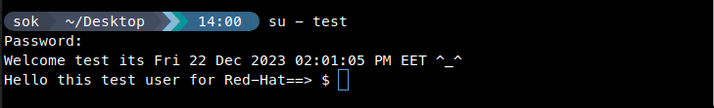
10.Execute the following command :

\ <==== for multi-line commands

11.Create a Bash shell alias named ls for the “ls –l” command
